SE MOODLE

SE CA 1

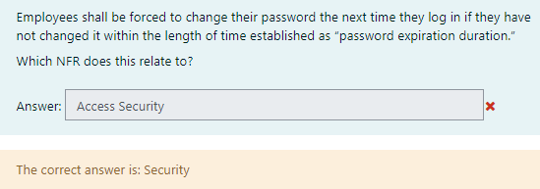

Employees shall be forced to change their password

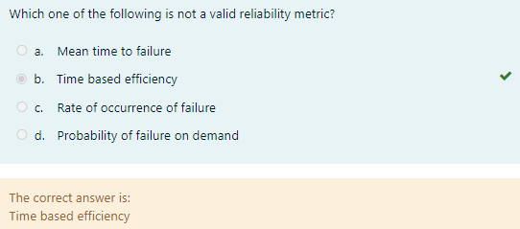

Which one of the following is not a valid reliability metric?

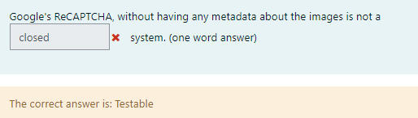

Google’s ReCAPTCHA, without having any metadata about the images is not a

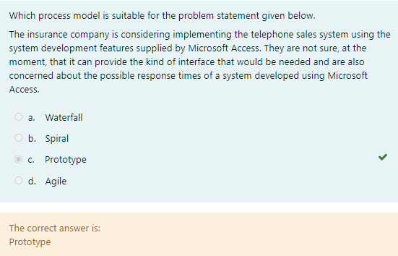

Which process model is suitable for the problem statement given below.

The insurance company is considering implementing the telephone sales system using the

system development features supplied by Microsoft Access. They are not sure, at the

moment, that it can provide the kind of interface that would be needed and are also

concerned about the possible response times of a system developed using Microsoft

Access.

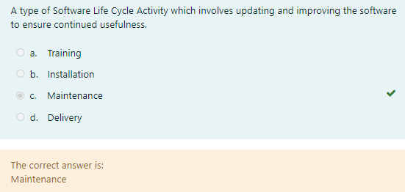

A type of Software Life Cycle Activity which involves updating and improving the software to ensure continued usefulness.

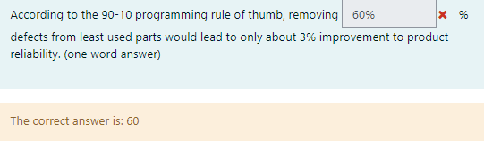

According to the 90-10 programming rule of thumb, removing _____

defects from least used parts would lead to only about 3% improvement to product

reliability.

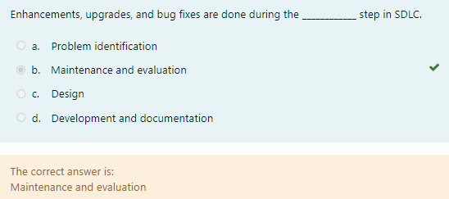

Enhancements, upgrades, and bug fixes are done during the step in SDLC.

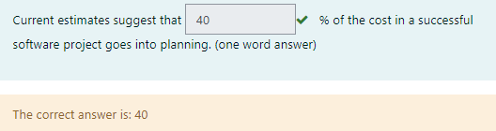

Current estimates suggest that ____ of the cost in a successful

software project goes into planning.

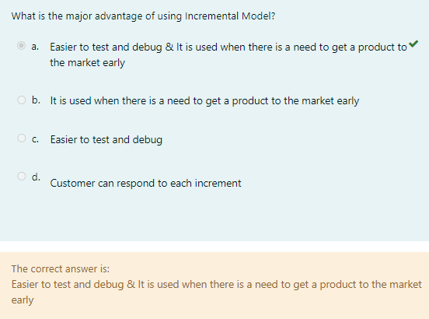

What is the major advantage of using Incremental Model?

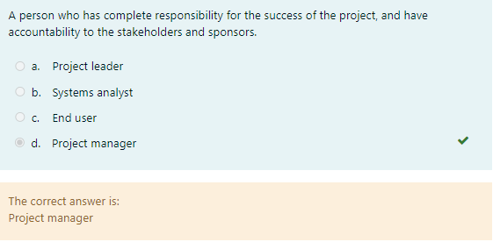

A person who has complete responsibility for the success of the project, and have

accountability to the stakeholders and sponsors.

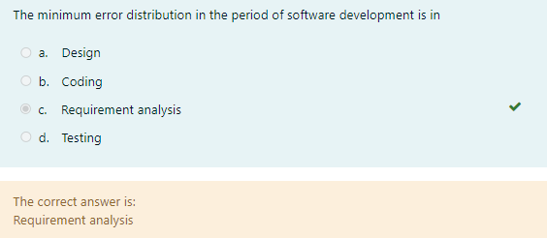

The minimum error distribution in the period of software development is in

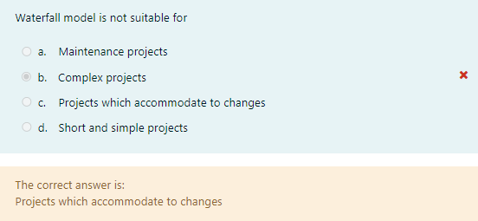

Waterfall model is not suitable for

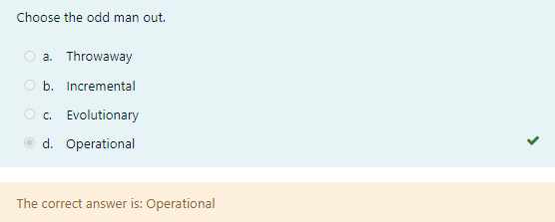

Choose the odd man out.

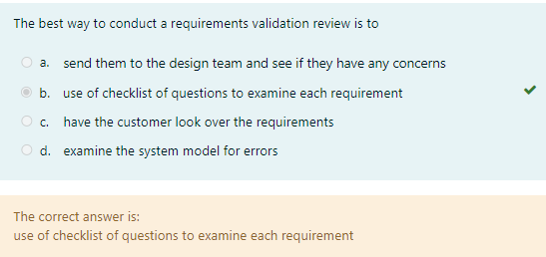

The best way to conduct a requirements validation review is to

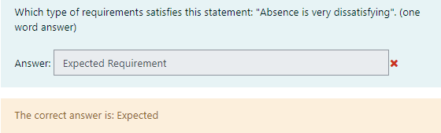

Which type of requirements satisfies this statement: "Absence is very dissatisfying". (one

word answer)

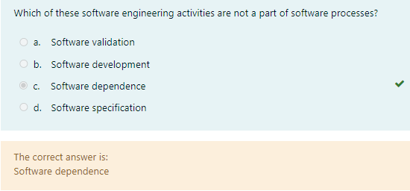

Which of these software engineering activities are not a part of software processes?

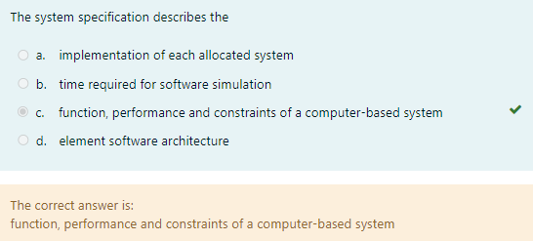

The system specification describes the

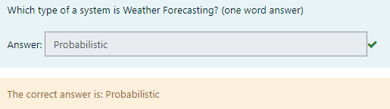

Which type of a system is Weather Forecasting? (one word answer)

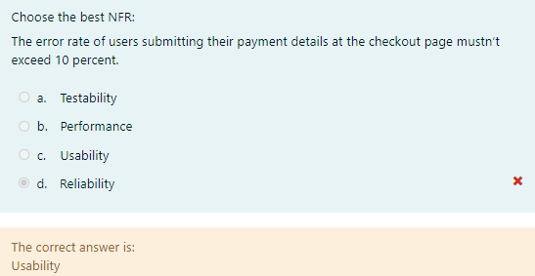

Choose the best NFR:

The error rate of users submitting their payment details at the checkout page mustn’t

exceed 10 percent.

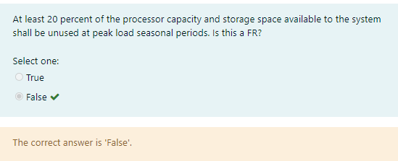

At least 20 percent of the processor capacity and storage space available to the system

shall be unused at peak load seasonal periods. Is this a FR?

SE TUT

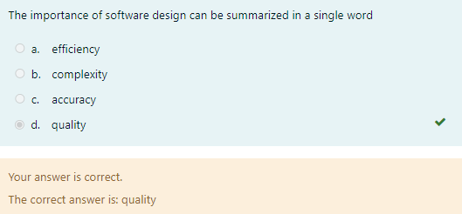

The importance of software design can be summarized in a single word

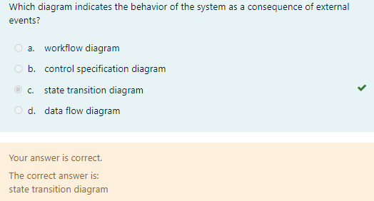

Which diagram indicates the behavior of the system as a consequence of external events?

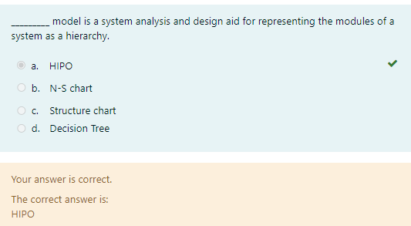

_____ model is a system analysis and design aid for representing the modules of a system as a

hierarchy.

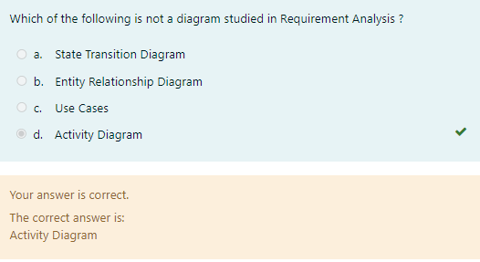

Which of the following is not a diagram studied in Requirement Analysis ?

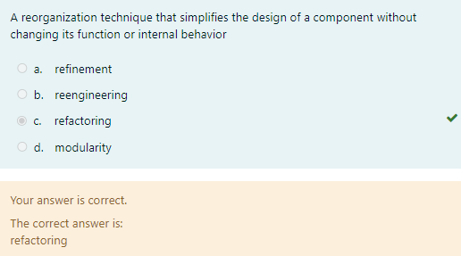

A reorganization technique that simplifies the design of a component without changing its function or

internal behavior

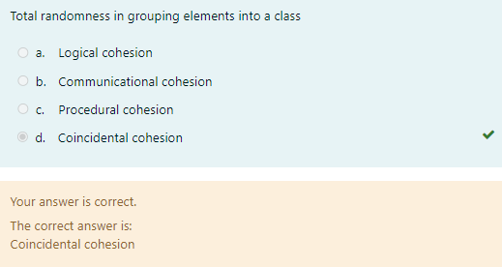

Total randomness in grouping elements into a class

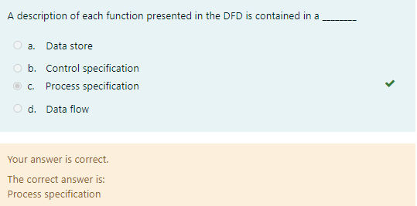

A description of each function presented in the DFD is contained in a _____

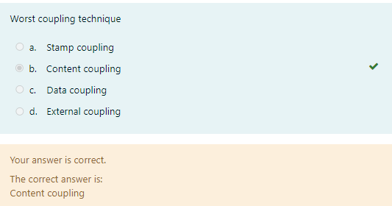

Worst coupling technique

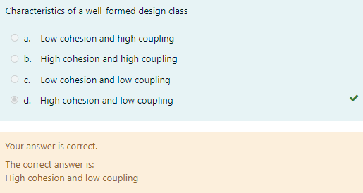

Characteristics of a well-formed design class

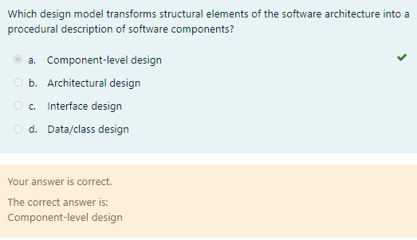

Which design model transforms structural elements of the software architecture into a procedural

description of software components?

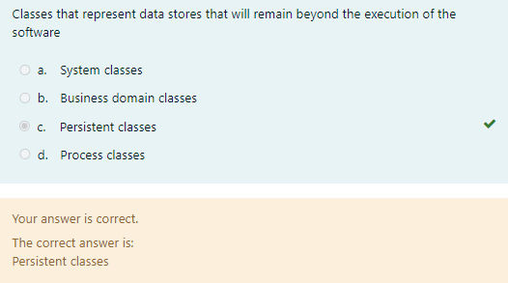

Classes that represent data stores that will remain beyond the execution of the software

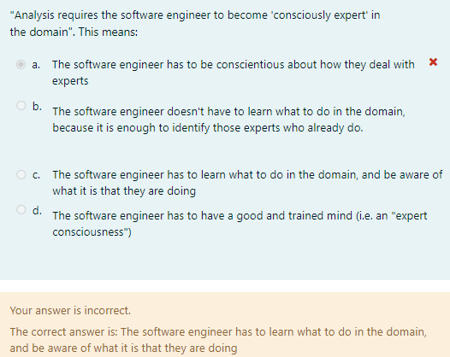

“Analysis requires the software engineer to become 'consciously expert' in the domain". This means:

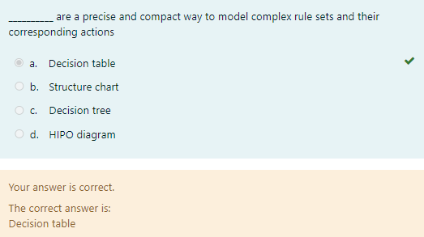

_______ are a precise and compact way to model complex rule sets and their corresponding actions

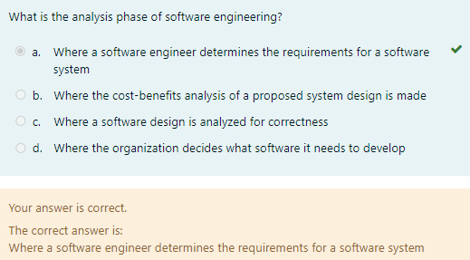

What is the analysis phase of software engineering?

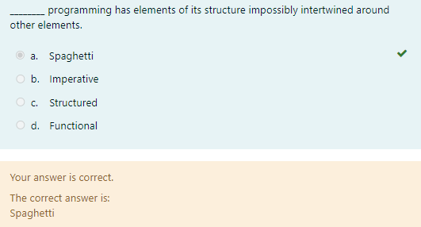

____ programming has elements of its structure impossibly intertwined around other elements.

SE CA 2

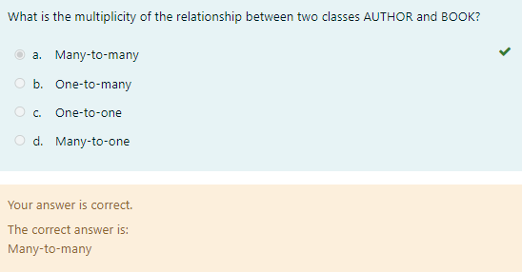

What is the multiplicity of the relationship between two classes AUTHOR and BOOK?

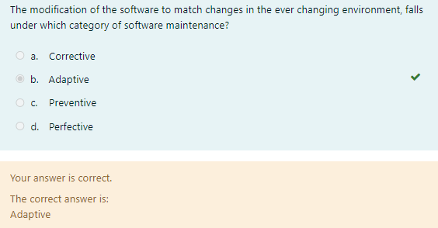

The modification of the software to match changes in the ever changing

environment, falls under which category of software maintenance?

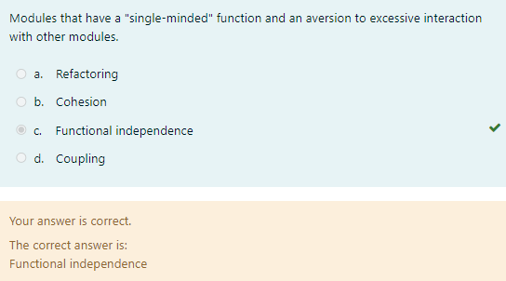

Modules that have a "single-minded" function and an aversion to excessive

interaction with other modules.

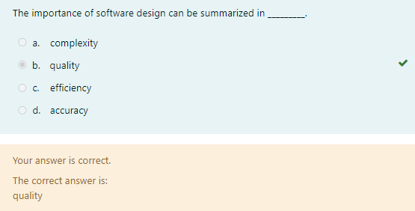

The importance of software design can be summarized in _____.

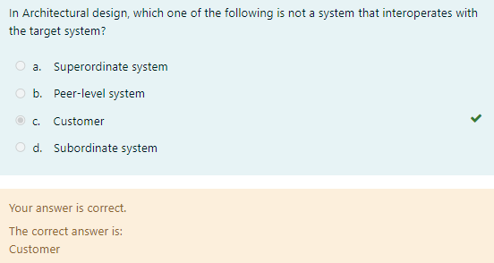

In Architectural design, which one of the following is not a system that interoperates

with the target system?

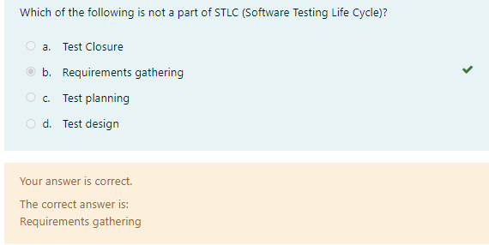

Which of the following is not a part of STLC (Software Testing Life Cycle)?

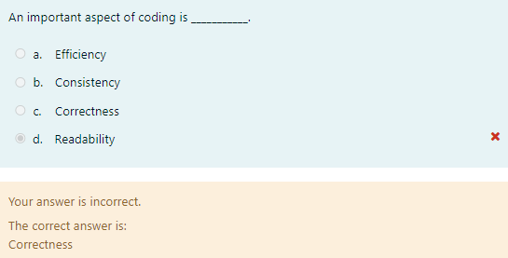

An important aspect of coding is ____.

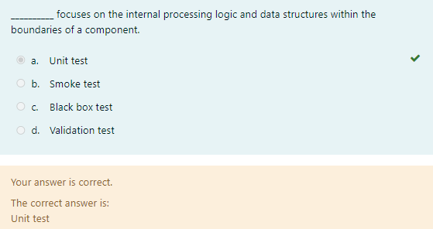

______ focuses on the internal processing logic and data structures within the

boundaries of a component.

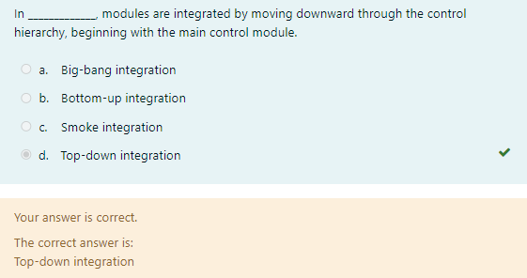

In ________ , modules are integrated by moving downward through the control

hierarchy, beginning with the main control module.

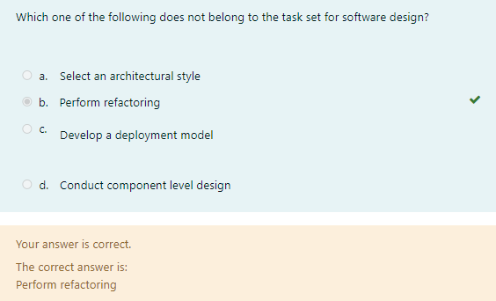

Which one of the following does not belong to the task set for software design?

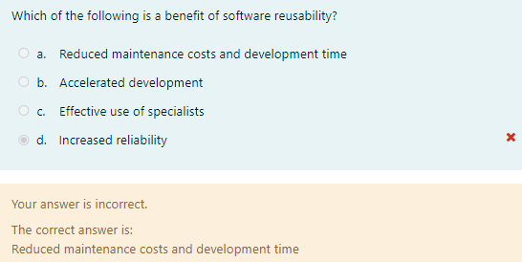

Which of the following is a benefit of software reusability?

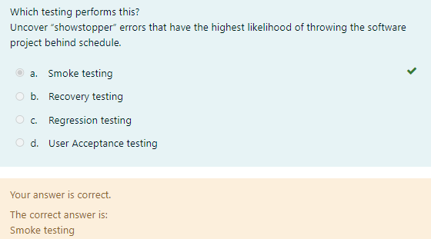

Which testing performs this?

Uncover ”Showstopper” errors that have the highest likelihood of throwing the

software project behind schedule.

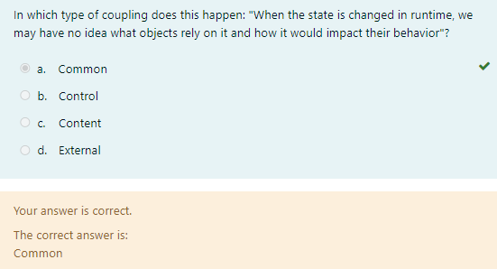

In which type of coupling does this happen: "When the state is changed in runtime,

we may have no idea what objects rely on it and how it would impact

their behavior"?

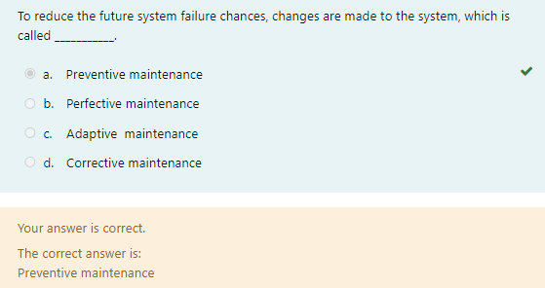

To reduce the future system failure chances, changes are made to the system, which

is called __________.

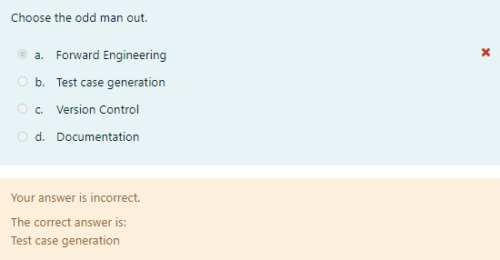

Choose the odd man out.

Forward Engineering

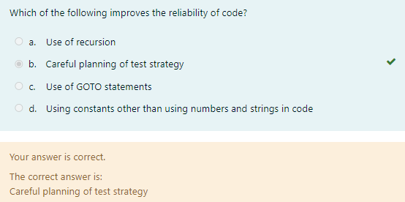

Which of the following improves the reliability of code?

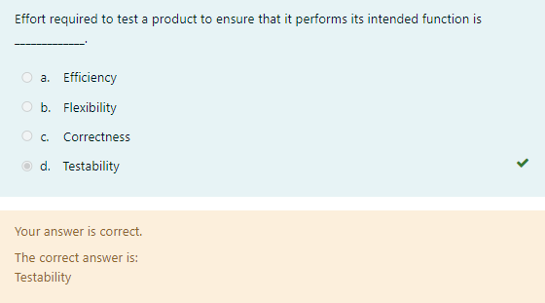

Effort required to test a product to ensure that it performs its intended function is _____.

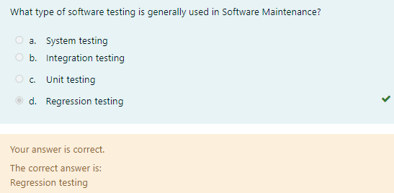

What type of software testing is generally used in Software Maintenance?

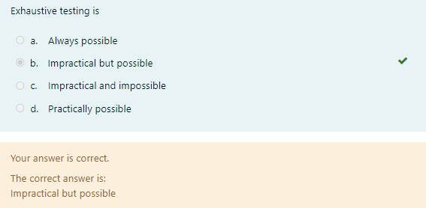

Exhaustive testing is

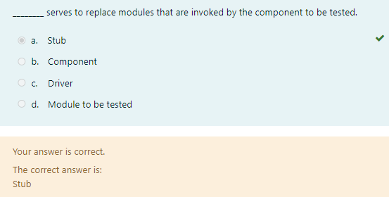

________ serves to replace modules that are invoked by the component to be tested.